LOW INCOME HOUSING for SENIORS 62+

Beacon Pointe Apartments
OPENING FALL 2019
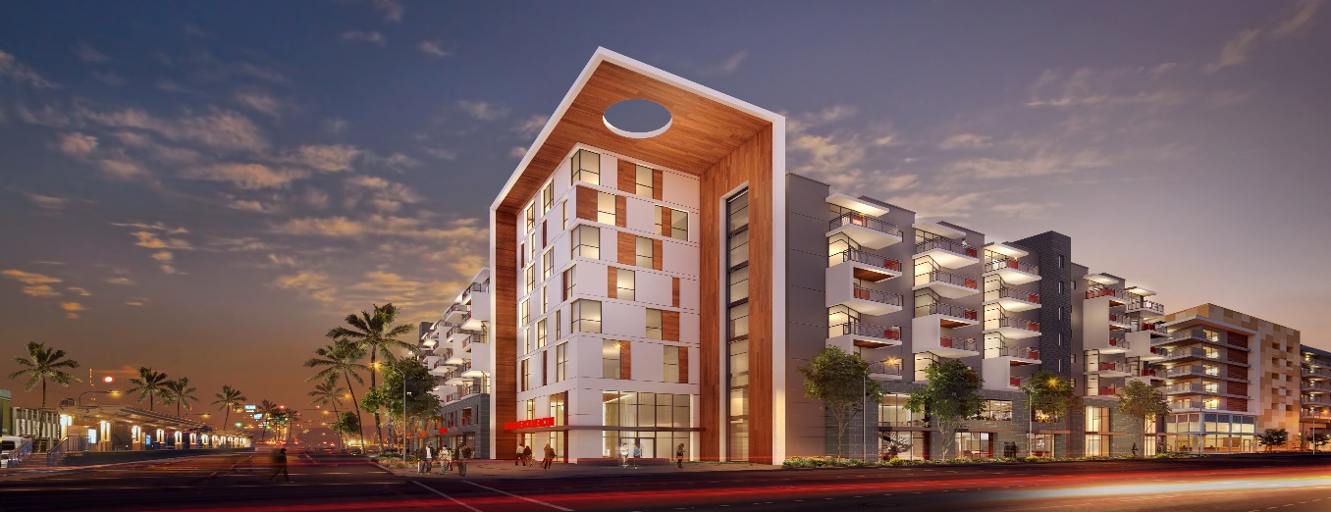

Case Managers/Homeless Providers/Applicants – Beacon Pointe is located at 1235 Long Beach Boulevard in Long Beach, California. Beacon Pointe offers a total of 120 units subsidized brand-new apartments for Seniors age 62 years and older. All household members must be at least 62 years of age.

Fifty-nine (59) units are designated for low-income Seniors age 62 years of age or older. Applicants may apply through the Housing Authority of the City of Long Beach (HACLB) website at www.longbeach.gov/haclb/apply or call 562-570-6985. Rents are subsidized through the Project Based Voucher (PBV) program administered by the Housing Authority. Tenants pay approximately 30% of their adjusted gross income as rent as determined by the HACLB.

Sixty-one (61) units are designated for Seniors age 62 years of age or older and experiencing homelessness. Applicants for these units will be referred through the Coordinated Entry System (CES) by the Multi-Service Center (MSC). Rents are subsidized through the Project Based Voucher (PBV) program administered by the Housing Authority. Tenants pay approximately 30% of their adjusted gross income as rent as determined by the HACLB.

Per the City of Long Beach local preference requirements, JSCO will administer a live or work in the City of Long Beach priority at Beacon Pointe. Preferences will only determine the order in which pre-applications are processed. Applicants will still need to meet all tenant eligibility requirements to be approved for occupancy. Priority eligibility proof, such as but not limited to, lease or rental agreement, pay check stubs, tax-returns, or bank statements, must be shown at the time of interview. For supportive housing units, preference eligibility will be determined by the Multi-Service Center (MSC) using third-party verifications prior to referral to JSCO for processing.

UNIT MIX INCLUDING INCOME RESTRICTIONS (Subject to change):

UNIT SIZE | # of UNITS | AMI | Occupancy Standards
 |  |  |  | 1 person maximum income | 2 person maximum income | 3 person maximum income | 4 person maximum income | 5 person maximum income
1BD | 15 | City 30% | 1-3 | $14,550 | $16,635 | $18,705
1BD | 15 | TCAC 30% | 1-3 | $20,370 | $23,280 | $26,190
2BD | 6 | City 30% | 3-5 |  |  | $18,705 | $20,790 | $22,455
2BD | 2 | TCAC 30% | 3-5 |  |  | $26,190 | $29,070 | $31,410

As required by the Tax Credit Allocation Committee (TCAC), mobility/hearing/sight impaired households will have priority for twelve (12) units designed for the mobility impaired, five (5) of which are designed for the hearing/sight impaired. Affordable rents are income-restricted in accordance with the Low-Income Housing Tax Credit (LIHTC) program and other regulatory agreements. Income limits are subject to change. Accessible Unit features include, wheelchair accessible doorways, accessible peepholes, lowered countertops, light switches, and cabinets, roll-under sinks, roll-in showers. Hearing/ Vision accessible fire alarms and doorbells.

All applicants will be referred by the Housing Authority of the City of Long Beach (HACLB) or through the Coordinated Entry System (CES) by the Multi-Service Center (MSC). Eligibility restrictions apply based on program and subsidy. Not all applicants referred will be offered a unit.

JSCO will process applications in the order received. Eligible applicants will be sent to The Housing Authority of the City of Long Beach (HACLB) for further processing and rent determination.

If you are a person with a disability and require any special accommodation due to your disability, please let an employee of the MSC or JSCO know what accommodations you require.

Applicants for the Supportive Housing units must meet the definition of homelessness as defined by the Department of Housing and Urban Development (HUD).

Homeless is defined by HUD as:

- An individual or family that (i) Is homeless and lives in a place not meant for human habitation, a safe haven, or in an emergency shelter;
- An individual who has been residing in an institutional care facility, including jail, substance abuse or mental health treatment facility, hospital, or other similar facility, for fewer than 90 days and met all of the criteria in paragraph (1) of this definition, before entering that facility; or

- A family with an adult head of household (or if there is no adult in the family, a minor head of household) who meets all the criteria in paragraph (1) of this definition, including a family whose composition has fluctuated while the head of household has been homeless.

The Multi-Service Center (MSC) and Mental Health America (MHA), will provide assistance with the application process by providing guidance to applicants in completing and organizing the paperwork necessary to determine eligibility.

Households comprised of ALL full-time student members do not qualify unless exempted by Section 42 of the Internal Revenue Code. Our complete Resident Selection Criteria is available at the Rental Office upon request.

BEACON POINTE APARTMENTS – APPLICATION PROCESS

Although applications are processed in the order received by JSCo, apartments will be offered on a First-Qualified, First-Offered basis.

Application
Referrals will be made by The Multi-Service Center (MSC) through the Coordinated Entry System (CES) or the Housing Authority of the City of Long Beach (HACLB). For supportive housing units, the MSC will determine if the applicant meet the programmatic requirements, including homelessness. Applicants meeting the specific requirements of the program, will be referred to The John Stewart Company (JSCO). JSCO will schedule an interview to further review the application and documents for eligibility.

Interview
For the scheduled appointment, applicants must provide all requested supporting documents as outlined in the Interview Checklist below. JSCo will confirm the information provided on the application, and answer any questions or concerns. This interview normally takes approximately 45 minutes. All persons who will be living in the apartment, irrespective of their age, must participate in this interview. The leasing associate must verify credit, criminal background check, rental history, and all sources of income and assets. Approved applicants will be referred to the Housing Authority of the City of Long Beach (HACLB) for their program eligibility and rent determination.

Apartment Offer
When all documents have been received, verified and approved by JSCO and HACLB, qualified applicants will be invited to view the apartment that has been selected for them. Applicants will only receive one offer for an apartment. If the applicant declines that apartment, the application will be considered withdrawn unless a verified mitigating circumstance is provided.

12 Month Lease Term
If the unit is accepted, the applicant will sign a lease. Leases will be for a minimum term of one year.

Pets
Residents may not keep any type of animal or pet on the premises, with the exception of those persons with disabilities requiring service animals, or as otherwise required by law.

Parking
There are a limited number of resident spaces at Beacon Pointe Apartments. Parking is restricted to cars owned by residents of Beacon Pointe Apartments. All cars must be registered in the name of the resident and residents must provide proof of current auto insurance and must provide a valid driver's license. All cars must be for personal use only, be in working order, and be maintained in a safe condition at all times. Vehicles not in compliance will be towed at the owner's expense. No exceptions. Accessible spaces are available.

INTERVIEW CHECKLIST

**DO NOT SUBMIT THIS INFORMATION WITH YOUR APPLICATION. THIS IS ONLY REQUIRED AT THE TIME OF INTERVIEW.**

If you choose to apply and we contact you for an interview, you will be required to provide the following information as applicable:
For household members 18 and older:

• Valid state or national picture ID (i.e. Driver’s License, Passport, etc).

• Employment: Copies of the first pay-stub for the current calendar year and the most current 3 months of consecutive pay-stubs (7 stubs if paid bi-weekly; 6 stubs if paid semi-monthly; 13 stubs if paid weekly) or equivalent proof of other income. A copy of the most recent IRS Tax Return is required for cash paid employment.

• Unemployment Insurance: Printout of statement or copy of last letter showing current monthly benefit.

• Self-Employment: Copy of last year IRS Tax Return including Schedule C and list of current or most recent clients.

• GA/AFDC/TANF: Printout of benefits paid in last 12 months or last Notice of Action letter (dated within 120 days)

• Pensions & Annuities: Copy of the most current statement

• Real Estate: Copy of the most recent mortgage statement & other relevant owner information.

• Student: Name and Address of school & copy of the unofficial class transcript.

For all household members of any age as applicable:

• Social Security Cards and Birth Certificates (for all members)

• SSI or SSA/Disability: Printout of the benefit letter (the date on the letter needs to be within 120 days prior to move in).

• Bank accounts and Assets: Copies of the 2 most recent bank statements for checking accounts; 2 most recent bank statements for savings account. (For electronic paycards: printout or receipt with current balance and copy of the paycard)

• Child Support/Alimony: Current notice from D.A. Office, a court order or a letter from the provider with copies of last 2 checks.

• Financial Assistance: This is regular gifts or payments from anyone outside of the household (includes anyone paying your bills). We will require a notarized written letter from the person providing assistance stating the amount and length of assistance, and bank/asset statements showing funds equaling 18 times the monthly assistance.

• Other: Documentation for regular pay as a member of the Armed Forces, severance payments, settlements, lottery winnings or inheritances, death benefits or life insurance dividends, trust benefits, or any other source of income Criteria is available at the Rental Office upon request.

